Task: - 1
Generate SOS Report: - Take the entire server / Vm configuration backup.
# sosreport
# Enter (No need to mention name it will take hostname by default)
# Enter case id or Ip for our understanding.
Less than RHEL version-7 the Sos report saves in the /tmp directory.
Report saved: - /var/tmp/sosreport-cltsrvmonlvm-10.3.0.34-2026-08-14-ygxhwxl.tar.xz

Task: - 2
DNS Configuration: -

Task: - 3
Mail Configuration: -
# mailq command uses to check the any mail is in the queue
# mail -s "Test” Kapildeo.patil1@ibm.com < /home/output.txt
# setup the SMTP (relay) server.
# /etc/postfix/main.cf
myhostname = mail.example.com
mydomain = example.com
myorigin = $mydomain
inet_interfaces = all
inet_protocols = ipv4
mydestination = $myhostname, localhost.$mydomain, localhost, $mydomain
relayhost =

Task: - 4
ESXi Host Vs vSphere: -
ESXi — VMware’s hypervisor installed directly on a physical server. It creates and runs virtual machines (VMs).
vSphere — VMware’s virtualization platform/suite. It includes ESXi plus management and other capabilities.
vCenter Server — The management component used to centrally manage multiple ESXi hosts, clusters, VMs, HA, DRS, vMotion, etc.
Simple architecture: - Physical Server → ESXi → Virtual Machines
vCenter Server is a multiple host manager:
vCenter Server
↳ ESXi Host 1 → VMs
↳ ESXi Host 2 → VMs
↳ ESXi Host 3 → VMs
NOTE: - ESXi is the hypervisor; vSphere is the overall VMware virtualization platform.

Task: - 5

Task: - 6
# free - h Check ram and swap.
# create swap memory.

Task: - 7
# ls -ltr check the mount point is accessible or not.
# df -h check all the mount point is available & % utilization.
Mount folder from A server to B server.
# df -h /mount folder path Check if the mount point exists and is mounted
# df -h /mount path If mounted, you will see filesystem details and disk usage.
# mountpoint /mount folder path Check mount status
# Output: /mount folder path is a mountpoint
# If not mounted: /mount folder path’ is not a mountpoint
# ls -ld /mount folder path Check if you can access/read the mount
# ls -l /mount folder path If we can list the contents, the mount is generally accessible.
# findmnt /data You can also check.
# mountpoint /data && df -h /mount folder path Quick check for routine Linux administration, I would use.

Task: - 8
Linux / AIX: - for oracle database
# Ps -ef | grep -i pmon check if the database is running or not

Linux: -
systemctl status mysqld check if the database is running or not
systemctl status postgresql check if the database is running or not

Task: - 9
Check the cpu consumption percentage- top
Check core wise press 1,

Task: -10
# dsmc q fi backup list check.
# dsmc q shed backup in queue
# dsmc i take backup

Task: - 11
How will I check the cpu consumption for the last 2 month?
# cd /usr/bin/sar
# ls -lh /var/log/sa/

sa01, sa02, sa03, sa04, sa05, sa06……..

# sar -u -f /var/log/sa/sa10

Important: - If sysstat/sar was not running during those two months, Linux normally cannot reconstruct historical CPU usage after the fact.
For future monitoring, install/enable sysstat
# sudo dnf install sysstat
# sudo systemctl enable --now sysstat

Task: - 12
I have saved my data in the form of tar, but the hacker hacks the server access and untar the data, how can we secure this data?
# tar -cf backup.tar /path/to/data
# gpg -c backup.tar
# rm -f backup.tar
# gpg -d backup.tar.gpg > backup.tar
# tar -xf backup.tar

Task: - 13

SELinux is enable and i have changed 22 default port to 2222 then can i take the ssh?
# sudo semanage port -a -t ssh_port_t -p tcp 2222

# Verify: - sudo semanage port -l | grep ssh
# output: - ssh_port_t tcp 22, 2222
# sudo systemctl restart sshd
# sudo firewall-cmd --permanent --add-port=2222/tcp
# sudo firewall-cmd --reload
# ssh -p 2222 username@server-ip

Task: - 14
How to clear the DNS cache what is the command?
# sudo resolvectl flush-caches
# resolvectl statistics check the DNS status.

Task: - 15
User expiry date, user adding, user removing
Task: - 16
Hard Drive Replacement: - call to storage admin, we have to share slot no & LE No (21L in the rack and 24 slots). share the serial no. & model number. Later cross verify BRU number & storage capacity of old & new Hard disk.

Task: - 17
1). Take a backup while update the package.
2). DNS name was not added in to the server, try from your side to add(mapping) the DNS name to (with) the IP address.
3). Check the installed package and kernel version.
4). Check the kernel version compatibility before installing or upgrade the package.
5). check the server health, server should work fine.
6). rpm -qa | grep -I package_name
7). ls -enable/disable check the service status.

Task: - 18
errpt ==> regarding lpar issue error check

errpt -aj identifer-ID ===> detal about Error

Error class = Hardware, Software, Operational, Unknown.
Error type = Permanent, Temporary, Information, Unknown.

topas ==> check load, memory, and cpu

ps -ef | grep -I pmon ==> check the database is available or not.

Task: - 19
Root user and normal user default permission.

root user (umask = 022)
mkdir india - 755 (max permission for folder = 777)
touch abc – 644 (max permission for file = 666)

normal user (umask = 002)
mkdir india - 775
touch abc – 664

umask value globally set in /etc/bashrc
for the user we can mention in the user default file, .bashrc

Task: - 20
nslookup ds1.ntpc.co.in
systemctl status ds_agent.service
ss -tulnp | grep ds
netstat -v

chronyc tracking # synchronization status
chronyc sourcestats -v # Statistics for each source
chronyc sources # normal output
chronyc sources -v # verbose output with more explanation/details.

Output:

^* time1.example.com # ^* — the currently selected NTP source.
^+ time2.example.com # ^+ — a source that is usable/combined.
^- time3.example.com # ^- — a source that is not currently selected.
? time3.example.com # ? — source is unreachable or not synchronized.

Task: - 21 – Set & Remove Password for the GRUB file
# cd /boot/grub-2/
# grub2-setpassword create the user.cfg file
# Enter password
# Confirm password
# grub2-mkconfig -o / boot/grub-2/grub.cfg update grub.cfg file
# rm -rf /boot/grub-2/user.cfg remove Password for the GRUB file.

# cd /boot/grub-2/
Press F2 for enter setup, F12 for network boot, Esc for boot menu

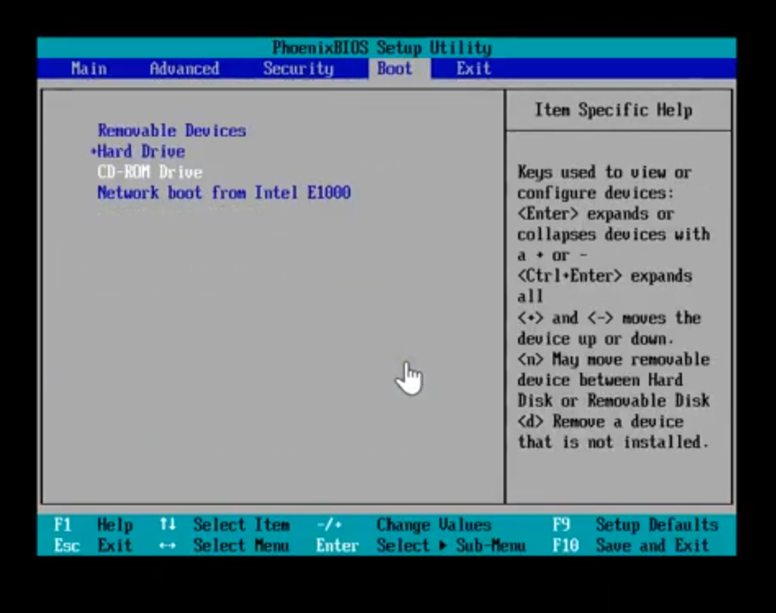

Go to the boot
Select CD-ROM Drive (shift & + move up, shift & - move down)
Go to Exit
Select Exit Saving Changes

Select the troubleshooting option and press enter

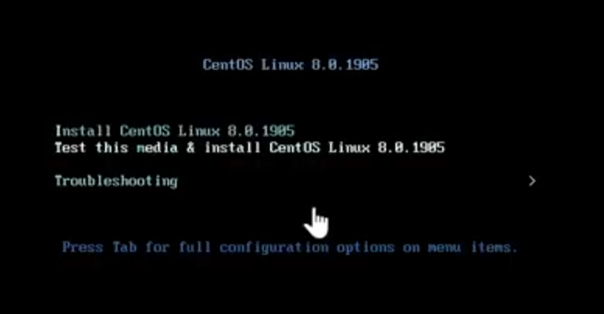

Select 2nd “rescue a centos linux system”

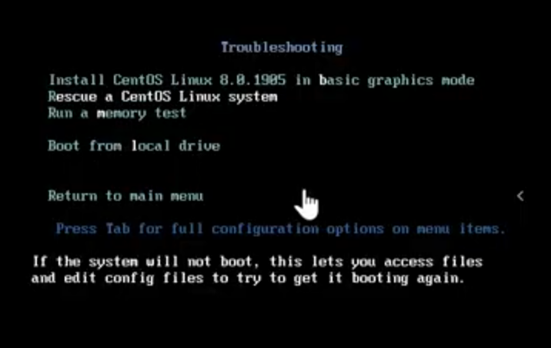

Enter 1 to continue

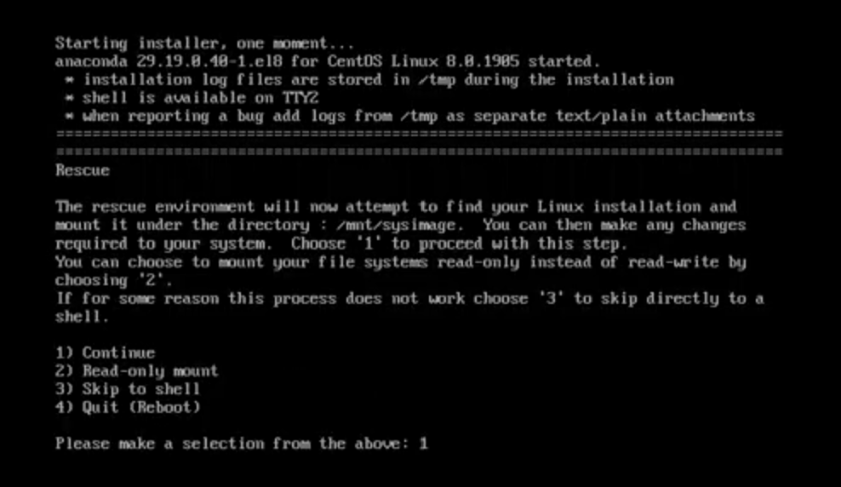

Press enters to get a shell
# Chroot /mnt/sysimage
# grub2-mkconfig -o / boot/grub-2/grub.cfg Get the recovery
# Exit
# Exit

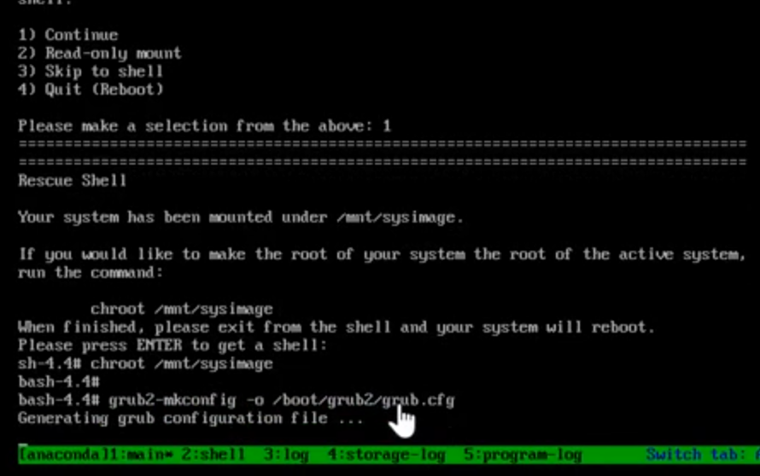

Press F2 for enter setup, F12 for network boot, Esc for boot menu
Go to the boot
Select Hard Drive (shift & + move up, shift & - move down)
Go to Exit
Select Exit Saving Changes

